
BENGALURU ROAD ACCIDENT EARLY WARNING SYSTEM:
A NEURAL NETWORK APPROACH FOR PREDICTIVE ACCIDENT-RISK MAPPING

Submitted by
Adarsh Pandey (2548101)
Likhith G Muthyalu (2548124)
Sharon M Varghese (2548137)

For the course
Course Code: MSTAT509A-4
Course Name: Neural Networks and Deep Learning
August – 2026
ABSTRACT

Bengaluru recorded over 32,000 road accidents between 2018 and 2024, with fatality patterns that are unevenly distributed across the city's 64 traffic police station jurisdictions. This project develops a neural-network-based early-warning system that predicts, one year in advance, whether a given station will fall among the city's ten most accident-prone locations. Seven years of station-wise accident records (fatal, non-fatal, injured, and killed counts) were cleaned, de-duplicated, and enriched with lag, rolling-average, and trend features. A feed-forward neural network (64-32-16-1 neurons, ReLU activations, dropout regularisation, class-weighted binary cross-entropy) was trained on a chronological split, with 2023 held out as the test year. The model achieved 85.3% test accuracy, 58.3% precision, 100% recall, an F1-score of 0.737, and a ROC-AUC of 0.984, correctly flagging every station that went on to become a high-risk hotspot the following year. Permutation-based feature importance identified prior fatal and non-fatal crash counts and rolling three-year averages as the strongest predictors. Final predictions were classified into HIGH/MEDIUM/LOW risk tiers, explained with human-readable risk indicators, and rendered on an interactive Folium map of Bengaluru for use by traffic-planning stakeholders. The system demonstrates that a lightweight neural network, trained on modest, publicly available administrative data, can provide a practical, explainable early-warning tool for urban road-safety planning.

TABLE OF CONTENTS
I. Introduction
II. Global and Contemporary Competencies
III. Literature Review
IV. Methodology
V. Result and Discussion
VI. Conclusion
Datasets

I. INTRODUCTION

ABOUT THE DOMAIN
Road traffic accidents are a leading urban safety and public-health challenge in rapidly growing metropolitan cities. Bengaluru, one of India's largest and most congested cities, has a dense, mixed-traffic road network spread across 64 active traffic police station jurisdictions. Traffic authorities publish annual station-wise accident statistics (fatal, non-fatal, injured, and killed counts), which are a rich but under-utilised source of information. Applying machine learning — and specifically deep learning — to this administrative data makes it possible to move from purely descriptive, after-the-fact accident reporting toward predictive, early-warning analytics that can support proactive road-safety planning, enforcement, and infrastructure investment.

PROBLEM STATEMENT
Existing accident reporting in Bengaluru is largely retrospective: totals are tabulated at the end of each year, and "accident hotspots" are identified only after the fact. This reactive approach means that resources such as patrolling, signage, speed-calming measures, and signal re-engineering are typically deployed only after a location has already suffered a spike in accidents. There is no widely accessible, data-driven tool that forecasts, ahead of time, which locations are likely to become high-risk in the coming year, nor one that explains why a location is flagged as risky. This project addresses that gap by formulating hotspot forecasting as a supervised binary-classification problem and solving it with a neural network.

OBJECTIVES
- To collect, clean, and consolidate seven years (2018–2024) of station-wise Bengaluru road-accident data, removing duplicate and aggregate rows to obtain a reliable station-level panel.
- To perform exploratory data analysis (EDA) to characterise annual trends, severity patterns, and the most consistently accident-prone stations.
- To engineer time-aware predictive features — previous-year counts, year-over-year change, and 2/3-year rolling averages — and to define a forward-looking "future high-risk" target label.
- To design, train, and validate a feed-forward neural network that predicts whether a station will be a top-10 accident hotspot in the following year, addressing class imbalance through class weighting.
- To evaluate the model using accuracy, precision, recall, F1-score, ROC-AUC, and a confusion matrix, and to interpret it using permutation feature importance.
- To translate model outputs into an actionable, explainable HIGH/MEDIUM/LOW risk classification, and to visualise station-level risk on an interactive geographic map of Bengaluru.

SCOPE
The project scope covers historical, publicly available station-level accident-count data for Bengaluru city (2018–2024) and is limited to a binary next-year hotspot-risk prediction at the traffic-police-station level. The model does not attempt individual-crash-level prediction (e.g., predicting a specific date, time, or crash type), nor does it incorporate real-time inputs such as live traffic, weather, or road-condition sensor feeds. The project further extends into visualisation and dissemination by geocoding stations and rendering predictions on an interactive map.

IMPORTANCE
An accurate, explainable early-warning system enables Bengaluru's traffic and urban-planning authorities to pre-emptively prioritise enforcement, infrastructure fixes, and public-awareness campaigns at locations likely to see a surge in accidents — rather than reacting only after casualties have already occurred. Because the model is deliberately tuned to minimise missed hotspots (false negatives), it is well suited to a safety-critical early-warning use case, where the cost of overlooking a genuinely dangerous location is far higher than the cost of an occasional false alarm.

OVERVIEW
The remainder of this report is organised as follows. Section II summarises how the project connects to global and contemporary competencies. Section III reviews related literature on accident hotspot prediction. Section IV describes the methodology, covering data collection, preprocessing, EDA, feature engineering, and the neural-network architecture. Section V presents results and discussion, including model performance, feature importance, and the final risk map. Section VI concludes the report and outlines directions for future work.

II. GLOBAL AND CONTEMPORARY COMPETENCIES

LRNG (LEARNING COMPETENCIES)
The project required self-directed learning of applied deep learning workflows — data wrangling with pandas, neural-network design in TensorFlow/Keras, handling class imbalance, and model interpretability — extending classroom concepts of neural networks into an end-to-end, real-world predictive analytics pipeline.

CROSS-CUTTING ISSUES
The project touches on urban public safety and equitable resource allocation: accident risk is not uniform across the city, and data-driven prioritisation can help direct limited traffic-safety resources to the areas of greatest need rather than the areas that are politically or historically prominent.

SUSTAINABLE DEVELOPMENT GOALS (SDG)
The work aligns most directly with SDG 11 (Sustainable Cities and Communities), which explicitly targets a reduction in road-traffic deaths and injuries, and contributes indirectly to SDG 3 (Good Health and Well-Being) by supporting interventions that can reduce fatal and non-fatal road-traffic injuries.

21ST CENTURY SKILLS
The project exercised computational thinking, data literacy, and problem decomposition, alongside applied skills in reproducible data pipelines, model evaluation under class imbalance, and communicating technical results (risk tiers, explanatory indicators, interactive maps) to non-technical stakeholders such as city planners and traffic police.

III. LITERATURE REVIEW
Road-accident hotspot identification has traditionally relied on descriptive statistical methods such as kernel density estimation and simple ranking of crash counts by location, which are useful for retrospective analysis but do not forecast future risk. More recent work has applied machine learning models — including logistic regression, random forests, and gradient-boosted trees — to accident-severity and hotspot-classification problems, generally reporting that ensemble tree-based methods perform well on small-to-medium tabular accident datasets but at some cost to interpretability.
Deep learning approaches, particularly feed-forward and recurrent neural networks, have increasingly been applied to traffic-accident prediction tasks where the relationship between historical accident patterns and future risk is non-linear and involves interactions across many engineered features (lagged counts, rolling averages, rate changes). Studies on imbalanced accident/incident classification consistently highlight the importance of class-weighting or resampling strategies, since "high-risk" events are typically a minority class, and note that recall (sensitivity) is often prioritised over precision in safety-critical early-warning contexts, since the cost of a missed hotspot substantially outweighs the cost of a false alarm.
Geospatial visualisation of predicted risk — commonly using interactive web-mapping libraries such as Folium/Leaflet — has also been identified in the literature as an important final step in translating model outputs into a form that is directly usable by traffic-planning and law-enforcement stakeholders. This project draws on these established directions: it combines time-aware feature engineering (as used in hotspot-forecasting literature), a class-weighted neural-network classifier suited to imbalanced safety data, permutation-based feature importance for interpretability, and an interactive geographic dashboard for dissemination, applied specifically to Bengaluru's traffic-police-station-level accident data.

IV. METHODOLOGY

DATA COLLECTION
The primary dataset, master_bengaluru_accidents_2018_2024.csv, contains station-wise annual road-accident statistics for Bengaluru covering the years 2018 to 2024. The raw file comprised 333 records across 11 columns: Zone, Sub-division, Station, Year, Fatal, Killed, Non-Fatal, Injured, Total, Fatal_Rate, and NonFatal_Rate, spanning 70 distinct station labels.

PREPROCESSING
Data cleaning proceeded in the following steps:
- Missing-value audit: Zone (1.5% missing), Sub-division (70.6% missing — dropped from modelling), Killed (16.5% missing), and Injured (16.5% missing) were profiled; the core Fatal, Non-Fatal, and Total counts used for modelling had no missing values.
- Removal of aggregate rows: the raw file contained zone-level summary rows (e.g., "North Total", "South Total") mixed in with individual station rows, which were double-counting accidents. These were identified and removed, reducing the dataset to 318 genuine station-year records across 64 unique stations.
- Station-name standardisation: inconsistent spellings of the same station (e.g., "White Field" vs. "Whitefield") were reconciled to a single canonical name using an explicit mapping dictionary.
- The cleaned panel was saved as intermediate CSV outputs (station_accident_summary.csv, yearly_accident_summary.csv, station_hotspot_consistency.csv) for downstream use.

EXPLORATORY DATA ANALYSIS (EDA)
EDA was carried out on the cleaned 318-row panel to characterise city-wide and station-level accident patterns. Citywide accident counts show a marked dip during the 2020–2021 pandemic years followed by a sharp rebound in 2023–2024. Kamakshipalya, Peenya, Whitefield, Electronic City, and Kengeri emerged as the five most accident-prone stations over the seven-year period, while Kamakshipalya and Electronic City appeared in the annual top-10 hotspot list in all seven years studied (100% consistency), making them the most persistently high-risk locations in the city. A station × year pivot heatmap and a fatal-vs-non-fatal severity breakdown were also produced to examine how accident composition varies over time and by location.
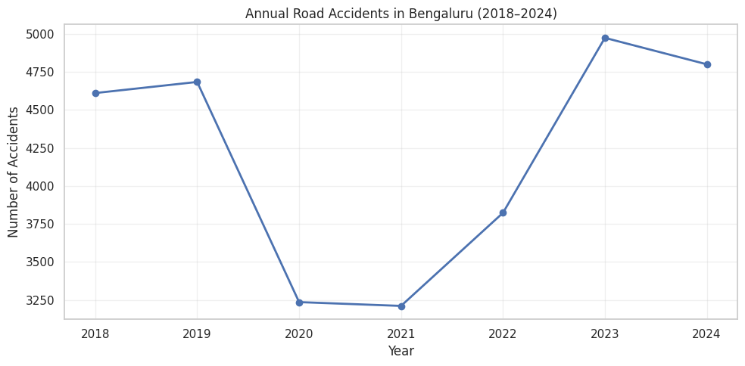
Fig. 1. Annual road accidents in Bengaluru, 2018–2024 (post-cleaning).
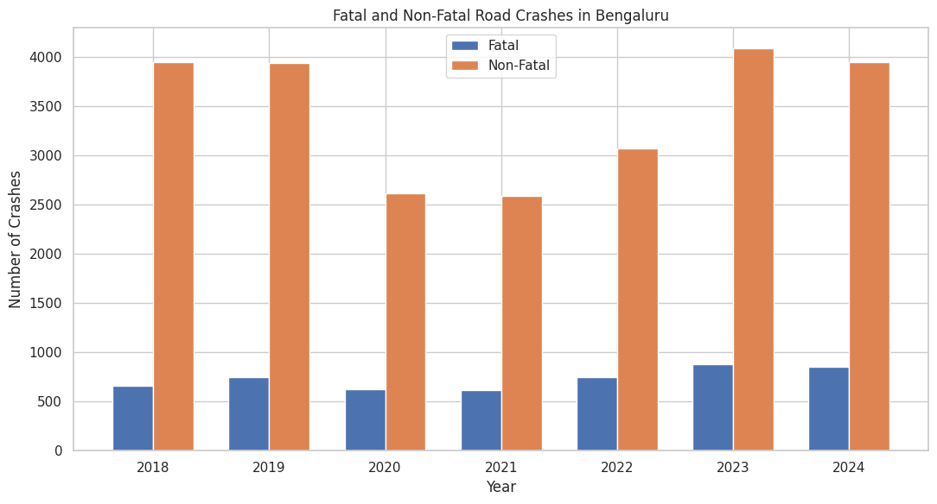
Fig. 2. Fatal vs. non-fatal crashes by year.
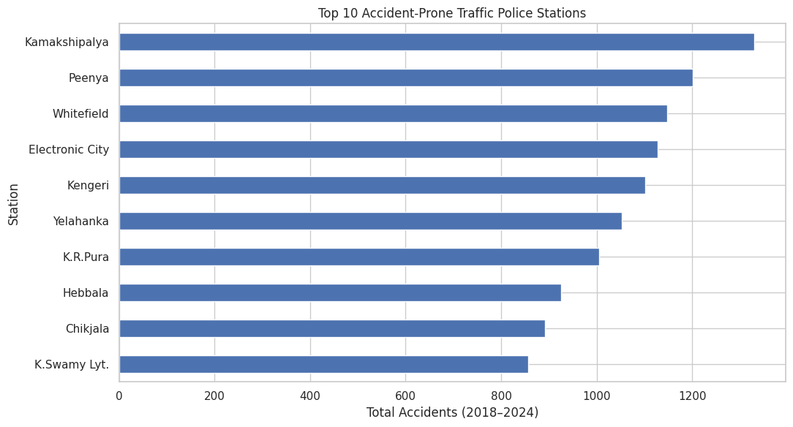
Fig. 3. Top 10 accident-prone traffic police stations, 2018–2024.

FEATURE ENGINEERING
To forecast risk one year ahead, the panel was restructured so that each station-year record carries information about its own recent history. The following engineered features were computed per station, ordered by year:
- Previous_Year_Accidents, Previous_Year_Fatal, Previous_Year_NonFatal — lagged one-year counts.
- Previous_Fatal_Rate, Previous_NonFatal_Rate — lagged severity rates.
- Accident_Change and Accident_Change_Percent — year-over-year change in total accidents.
- Rolling_2Year_Avg and Rolling_3Year_Avg — short-term rolling averages of total accidents, smoothing single-year volatility.
The prediction target, Future_High_Risk, was defined by ranking stations by total accidents within each year and flagging a station-year record as 1 if that station's rank in the following year falls within the top 10 (i.e., it becomes a top-10 hotspot), and 0 otherwise. After dropping rows with insufficient history to compute lag and rolling features, 156 station-year records remained for modelling, of which 38 (24.4%) were labelled high-risk and 118 (75.6%) were labelled not high-risk — confirming a moderate class imbalance that was addressed during training.

MODEL DESCRIPTION
Data Splitting
A chronological (time-aware) train/validation/test split was used to avoid information leakage from the future into the past: all station-year records from before 2023 (122 rows) were used for training and validation, and all 2023 records (34 rows) were held out as an untouched test set representing genuine one-year-ahead forecasting. The pre-2023 pool was further split into 88 training rows and 34 validation rows. Class proportions were checked across splits (train 22.7% high-risk, validation 32.4% high-risk, test 20.6% high-risk) to confirm the imbalance was reasonably preserved.
Feature Encoding and Scaling
The 14 numeric engineered features were standardised using scikit-learn's StandardScaler (fit on the training set only). The categorical Station identifier was transformed using one-hot encoding, expanding into 44 binary indicator columns. The final model input consisted of 58 features per record (14 scaled numeric features + 44 one-hot station indicators).
Network Architecture
A feed-forward (fully connected) neural network was built using TensorFlow/Keras' Sequential API:
Layer | Units | Activation | Notes
Dense (input) | 64 | ReLU | 3,776 parameters; input dim = 58
Dropout | — | — | Rate = 0.30
Dense (hidden) | 32 | ReLU | —
Dropout | — | — | Rate = 0.20
Dense (hidden) | 16 | ReLU | —
Dense (output) | 1 | Sigmoid | Binary risk probability

The network was compiled with the Adam optimiser (learning rate = 0.001), binary cross-entropy loss, and tracked accuracy, precision, recall, and AUC during training. Class weights, computed with scikit-learn's compute_class_weight, were passed to model.fit() to compensate for the 76/24 class imbalance and discourage the model from trivially predicting the majority class. An EarlyStopping callback (monitoring validation loss, patience = 15 epochs, restoring best weights) was used to prevent overfitting, with training run for up to 150 epochs at a batch size of 8; training converged and stopped early at epoch 21.

TOOLS AND LIBRARIES
- Python 3 (Google Colab environment)
- pandas, NumPy — data loading, cleaning, and feature engineering
- Matplotlib, Seaborn — exploratory data visualisation
- scikit-learn — StandardScaler, OneHotEncoder, compute_class_weight, permutation_importance, and evaluation metrics
- TensorFlow / Keras — Sequential model, Dense/Dropout layers, Adam optimiser, EarlyStopping
- Folium — interactive geographic risk-map visualisation
- Google Drive — dataset and output storage

V. RESULT AND DISCUSSION

ABOUT THE DATASET
After cleaning, the modelling dataset comprised 156 station-year records (64 unique Bengaluru traffic police stations, years 2018–2024) enriched with lagged and rolling accident features. The target variable, Future_High_Risk, was imbalanced (75.6% not-high-risk vs. 24.4% high-risk), which motivated the use of class-weighted training. A chronological split reserved the full year 2023 (34 records) as an unseen test set, ensuring the reported performance reflects genuine one-year-ahead forecasting rather than random interpolation.

MODEL PERFORMANCE
On the held-out 2023 test set, the trained neural network achieved the following performance:
Metric | Value | Percentage
Accuracy | 0.8529 | 85.29%
Precision | 0.5833 | 58.33%
Recall | 1.0000 | 100.00%
F1-Score | 0.7368 | 73.68%
ROC-AUC | 0.9841 | —

The confusion matrix on the test set (22 true negatives, 5 false positives, 0 false negatives, 7 true positives) confirms that the model correctly identified every station that actually became a top-10 hotspot in 2023 — a perfect recall of 100%, at the cost of 5 stations being flagged as high-risk that did not ultimately rank in the top 10 (false positives). For an early-warning safety application, this trade-off is a deliberate and desirable one: missing a genuine hotspot (a false negative) carries a far higher real-world cost — in potential injuries and fatalities — than the comparatively minor cost of an occasional unnecessary precaution at a false-positive location.
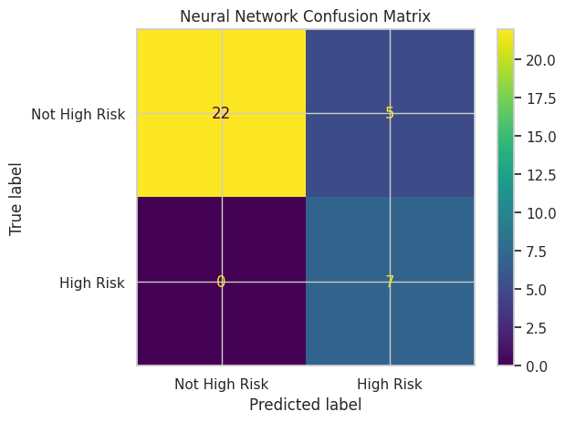
Fig. 4. Confusion matrix of the neural-network classifier on the 2023 test set.
TRAINING AND VALIDATION EVALUATION
In addition to the held-out 2023 test-set evaluation reported above, the final model was also evaluated on the training and validation splits at the epoch corresponding to the restored best weights (EarlyStopping, monitoring validation loss, patience = 15). Training ran for 21 epochs in total, with the lowest validation loss (0.294) reached at epoch 6; Keras' restore_best_weights therefore reverted the network to its epoch-6 state before evaluation, and it is this checkpoint that was compared across all three splits.
Metric | Training (restored-weights epoch) | Validation (restored-weights epoch)
Accuracy | 86.36% | 88.24%
Precision | 63.33% | 81.82%
Recall | 95.00% | 81.82%
F1-Score | 0.760 | 0.818
ROC-AUC | 0.949 | 0.941
Loss (Binary Cross-Entropy) | 0.327 | 0.294

The training and validation figures are close to one another (accuracy within two percentage points, F1-scores of 0.760 and 0.818 respectively), indicating that the dropout regularisation (0.30 and 0.20) and early stopping were effective in preventing the network from overfitting the small 88-row training set. Precision is lower on the training split than on validation because the training metrics are logged with dropout still active during the forward pass, which adds noise to the raw training predictions; this is expected Keras behaviour and is not indicative of a modelling problem, since validation and test metrics (computed with dropout switched off) are the ones that reflect genuine generalisation.
Recall remains high across all three splits (95–95–100%), confirming that the class-weighted loss consistently biased the model toward catching high-risk stations rather than the majority (not-high-risk) class, on data the model was trained on as well as on completely unseen 2023 data. The jump in test recall to a perfect 100% should be read alongside the very small positive class in the test set (7 of 34 stations); with so few positive examples, a single additional true positive has a large effect on the recall statistic. Taken together, the training, validation, and test results tell a consistent story: the network generalises reasonably well from a small dataset, is not memorising individual stations, and is deliberately tuned — across all three splits — to minimise missed hotspots even at some cost to precision.

TRAINING BEHAVIOUR
Training and validation curves show the model's loss decreasing steadily before early stopping intervened at epoch 21 to preserve the best-performing weights, while training accuracy climbed toward 95% and validation accuracy stabilised around 85–88%, indicating the dropout regularisation and early stopping were effective in controlling overfitting on this small dataset.
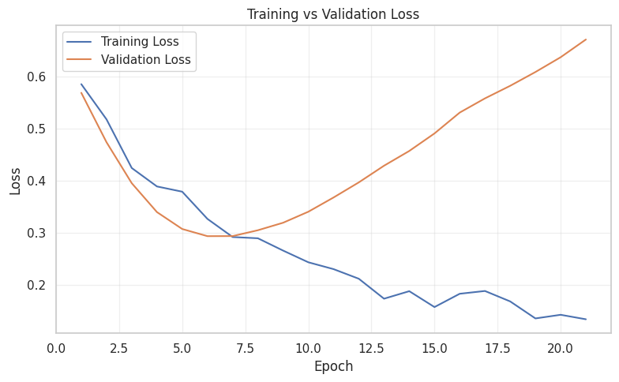
Fig. 5. Training vs. validation loss across epochs.
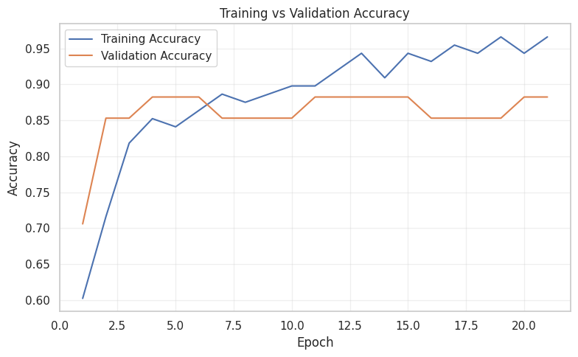
Fig. 6. Training vs. validation accuracy across epochs.

FEATURE IMPORTANCE
Permutation feature importance (measured as the drop in test ROC-AUC when a feature's values are randomly shuffled) identified the raw prior Fatal and Non-Fatal crash counts as the two most influential predictors, followed by the Rolling_3Year_Avg, Accident_Change, and Previous_NonFatal_Rate features. This indicates the model relies primarily on a station's own recent severity and volume history — rather than which specific station it is — to forecast future risk, which is a desirable and generalisable behaviour for an early-warning system.
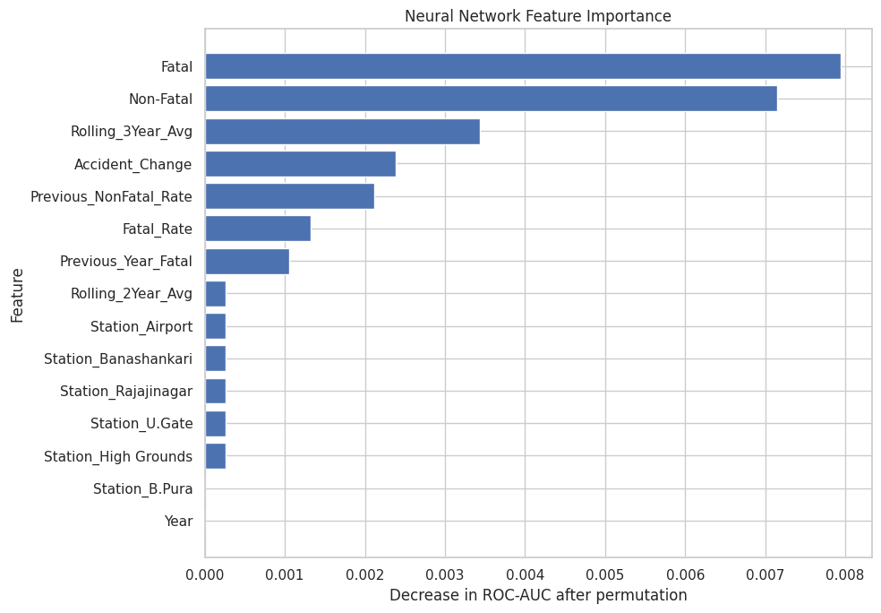
Fig. 7. Permutation feature importance (top predictors) for the neural-network model.

RISK CLASSIFICATION AND GEOGRAPHIC VISUALISATION
Model output probabilities were converted into three actionable risk tiers — HIGH (probability ≥ 0.70), MEDIUM (0.40–0.69), and LOW (< 0.40) — and paired with automatically generated, human-readable risk indicators (e.g., elevated fatal-crash counts, rising accident trend, high rolling average) explaining why each station received its classification. These station-level predictions were merged with geocoded station coordinates and rendered as an interactive Folium map of Bengaluru (bengaluru_accident_early_warning_map.html), allowing a user to click any marker and inspect its predicted risk probability and the specific factors contributing to that classification.
Of the 28 geocoded stations in the final deployment map, 8 were classified HIGH risk, 3 MEDIUM risk, and 17 LOW risk. The HIGH-risk stations — Electronic City, Whitefield, Chikkajala, Hebbal, Yelahanka, Peenya, Kamakshipalya, and Kengeri — align closely with the persistent hotspots identified during EDA (Section IV), lending face validity to the model's predictions. A static reproduction of the deployed map is shown in Fig. 8; the fully interactive version, with per-station explanations, is supplied alongside this report as bengaluru_accident_early_warning_map.html.
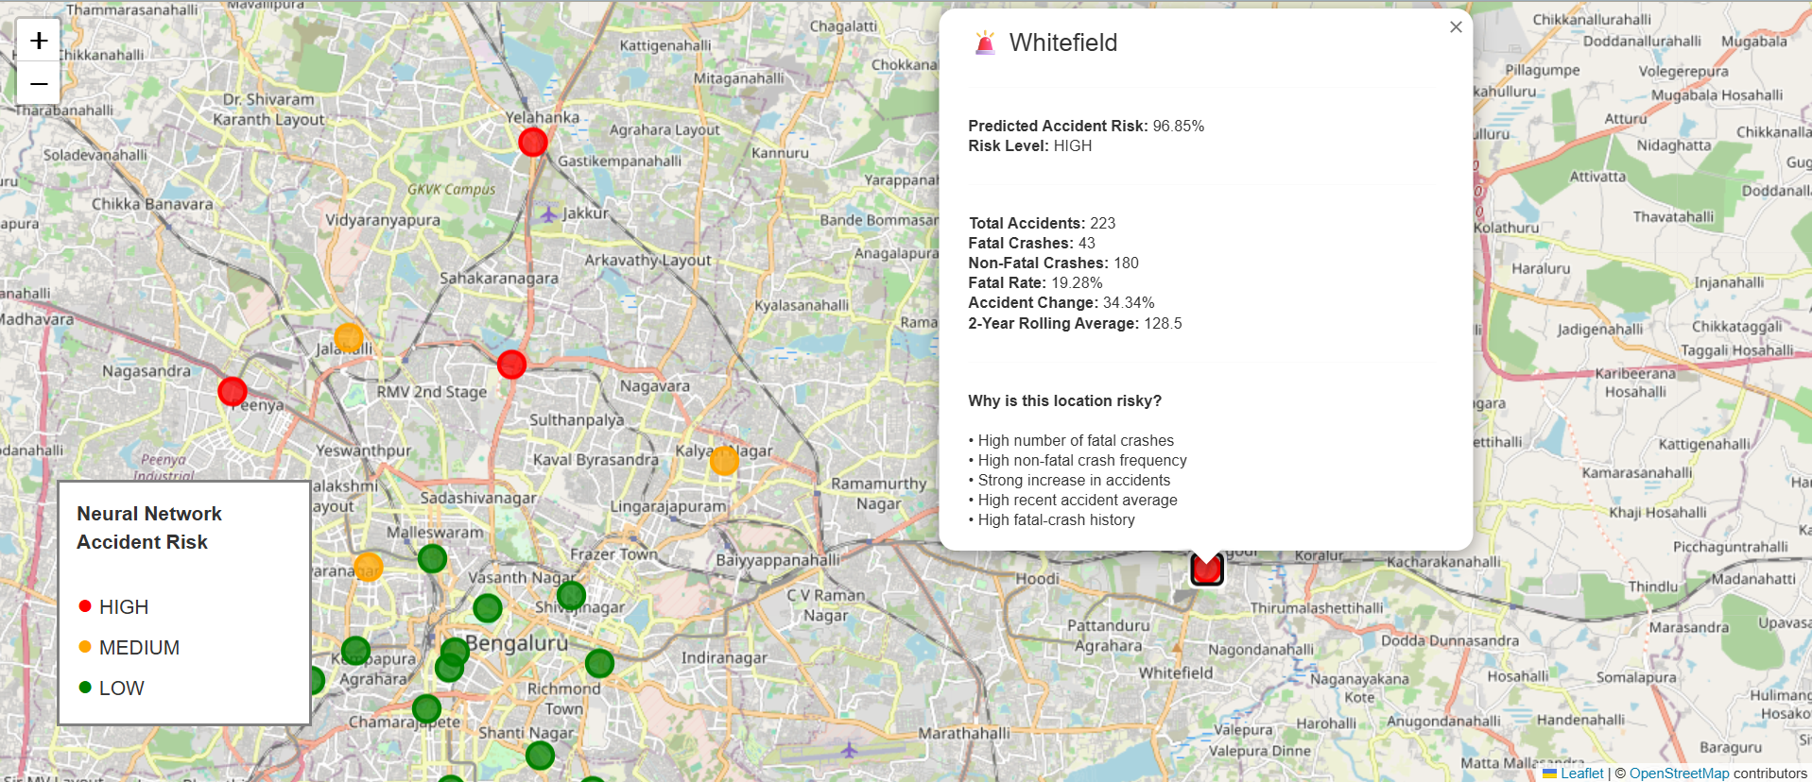
Fig. 8. Predicted accident-risk map of Bengaluru traffic police stations, reproduced from the interactive Folium dashboard (green = LOW, orange = MEDIUM, red = HIGH risk).
The complete set of results was exported for downstream use, including FINAL_NN_MODEL_METRICS.csv, FINAL_CONFUSION_MATRIX.csv, FINAL_RISK_DISTRIBUTION.csv, FINAL_TOP_10_HIGH_RISK_STATIONS.csv, FINAL_ACCIDENT_RISK_PREDICTIONS.csv, and the interactive bengaluru_accident_early_warning_map.html dashboard.

DISCUSSION
The results confirm that a compact neural network trained on modest, seven-year administrative accident data can meaningfully forecast next-year hotspot risk, achieving a ROC-AUC of 0.984 that indicates strong overall discriminative power between high-risk and low-risk stations. The 100% recall is especially valuable for a public-safety early-warning tool, since the primary operational goal is to ensure no genuinely dangerous location is overlooked. The comparatively lower precision (58.3%) reflects the conservative, safety-first decision threshold and the small absolute size of the positive (high-risk) class in the test set (7 of 34 stations); with only 34 test records, each individual misclassification has a large effect on the precision statistic. Overall, the model's behaviour — high recall, strong ranking ability (AUC), and interpretable feature drivers — is well aligned with the intended early-warning use case, where flagging a slightly wider set of at-risk locations for review is preferable to missing a true hotspot.

VI. CONCLUSION

SUMMARY
This project designed, built, and evaluated a neural-network-based early-warning system for forecasting road-accident hotspots in Bengaluru one year in advance. Starting from raw, partly duplicated administrative accident records, a clean seven-year (2018–2024) station-level panel of 64 traffic police stations was constructed, enriched with lagged and rolling-average features, and used to train a class-weighted feed-forward neural network. On an unseen 2023 test set, the model achieved 85.3% accuracy, 100% recall, and a ROC-AUC of 0.984 — correctly identifying every station that went on to become a genuine top-10 accident hotspot. Permutation feature importance confirmed that a station's own recent fatal and non-fatal crash history, rather than its identity, drives the prediction, supporting the model's generalisability. Final predictions were organised into explainable HIGH/MEDIUM/LOW risk tiers and visualised on an interactive Bengaluru map, combining historical hotspot analysis, neural-network prediction, explainable risk indicators, and geographic visualisation into a single, practical, AI-based road-accident early-warning framework.

FUTURE WORK
- Incorporate additional real-time or higher-resolution features — such as traffic volume, weather, road/lane geometry, and time-of-day/day-of-week patterns — where such data becomes available for Bengaluru.
- Extend the target from a binary top-10 hotspot label to a continuous or multi-class severity forecast (e.g., predicted accident count or graded risk score).
- Validate the model's generalisability on a larger, multi-city dataset and across additional future years as new data is published.
- Deploy the risk-scoring pipeline and map as a live, periodically refreshed dashboard for use by Bengaluru traffic police and city planning authorities.
- Compare the neural network against gradient-boosted tree baselines (e.g., XGBoost, Random Forest) to quantify any additional gain from the deep-learning approach on this dataset size.

DATASETS
- BTP - Station-wise accidents & fatalities 2018 to 2020:
https://data.opencity.in/dataset/bengaluru-road-crashes-data/resource/fcc5762c-2739-4c86-93fd-67fa4cca0750
- BTP - Station-wise accidents & fatalities 2020 to 2022:
https://data.opencity.in/dataset/bengaluru-road-crashes-data/resource/b3744a95-e486-4022-9c20-ad178dcf23dd
- BTP - Station-wise accidents & fatalities 2023:
https://data.opencity.in/dataset/bengaluru-road-crashes-data/resource/8f0f281c-2cb6-4491-ac76-d1874ce38583
- Station-wise Total Crashes and Fatal Crashes 2024:
https://data.opencity.in/dataset/bengaluru-road-crashes-data/resource/e59bc255-7b94-49df-b934-9b40fb2cc741
- Bengaluru Urban Traffic Police Stations Map:
https://data.opencity.in/dataset/traffic-police-station-locations-in-karnataka-and-bengaluru-urban/resource/94ff1e77-8955-40b3-bcf5-57b956f107aa

